The Family Educational Rights and Privacy Act (FERPA) is a federal law that secures the privacy of your educational records. This includes your grades, class schedule and financial aid information. However, you may want someone, other than yourself, to access to this information.
You may authorize an individual, such as a parent or guardian, to be a Third Party User whereby granting access. To authorize, you must complete two steps:
STEP 1: Add contact to your Friends and Family tab
STEP 2: Authorize contact as a Third Party User

Use this guide to add a contact and authorize the contact as a Third Party User.

LOCATE YOUR FRIENDS AND FAMILY TAB
- Log into Workday. Click the Profile icon in the top right corner.

- Click “View Profile”.

- Click “Contact”.

- Click the “Friends and Family” tab.

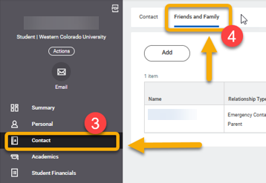
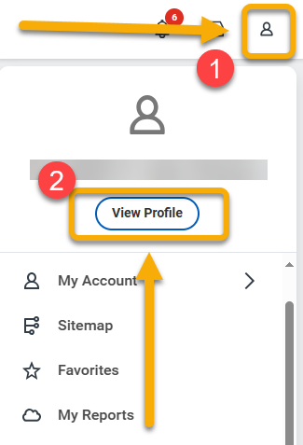

ADD and AUTHORIZE CONTACT
- From the Friends and Family tab, click “Add”.

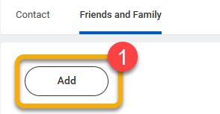

- On the Add My Friends and Family page, review the top portion of the form. Select “Relationship Type”. This is a required field.

In this example, the new contact is both the emergency contact and a parent.
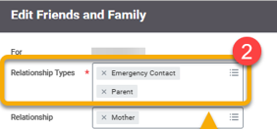

- Locate the Is Third Party User checkbox. To authorize this contact to have access to your educational record, check the box.
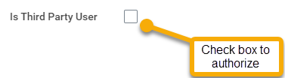

- If you check the box, an alert will appear. For now, it can be ignored. You will grant permissions later.


You must still grant permissions to this third-party user. After you complete this task, access the Manage Permissions for Third Party task that displays on your Friends and Family profile group.

- Continue to the Name section. If there is not a blue line under Name, click to select. Complete required fields.

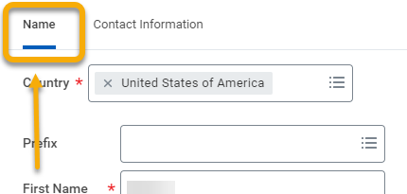

- Click “Contact Information” and complete required fields.

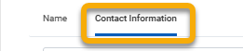
 Verify the email address is entered correctly. This address will receive a confirmation email to complete access to your records. If this confirmation is not received, contact should check their spam folder.

- When finished, click “OK” and click “Done”.

MANAGE PERMISSIONS
You now have a contact identified as a Third Party User. To complete authorization, you need to specify the information the contact has permission to access. You can change permissions at any time.

      - From the Friends and Family tab, locate the contact. Scroll to the right and click the “Actions” drop down menu to reveal and click “Manage Permissions for My Third Party”.

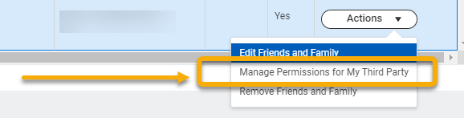

      - The Manage Permissions for My Third Party window will appear. Click “OK”.

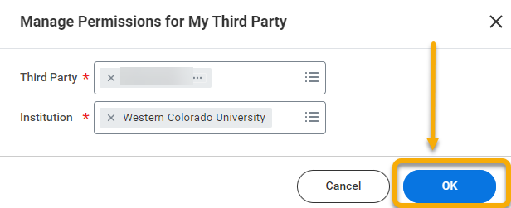

      - There are four permissions available to your third party user. Review each and click “Allowed” next to those you want the user to be able to do. Below is a review.

Permission | Description
View Financial Aid Package | Allows the third party user to see the student’s financial aid details, including estimated costs for the year.
View Current Classes | Allows the third party user to see the classes the student is currently registered for.
View Student Grades | Allows the third party user to see the student’s grades.
Generate Unofficial Transcript | Allows the third party user to see the student’s unofficial transcript.

      - After your selections are made, click “OK”.

      - The Privacy Release Authorization Waiver screen will appear. Read the waiver carefully.

In the Purpose of Waiver field, enter a brief explanation for the authorization. Examples may include, “Permit my parent to view my account information” or “Permit my guardian to review my financial aid information”.

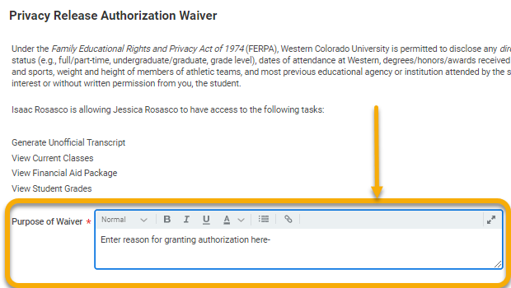

      - When finished, click “Confirm” and click “Submit”.

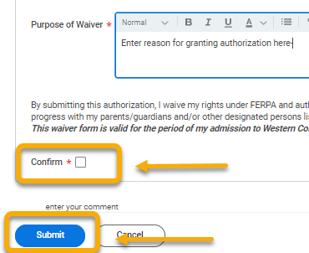

The Third Party you designated will receive an activation message at the email address you provided. They must complete the steps in that email to be able to access your account.

